**Wireless Sensor Networks (WSNs)**

Bolocan Crina-Maria1, Catrina Alexandra-Marilena2, Gușe Ovidiu-Marius3, Văduva Matias4

*Beia Consult International,*

*Bucharest , Romania,*

[*bolocancrinamaria13@gmail.com*](mailto:bolocancrinamaria13@gmail.com)*,* [*alexandracatrina554@gmail.com*](mailto:alexandracatrina554@gmail.com)*,*

[*ovidiu_marius.guse@stud.etti.upb.ro*](mailto:ovidiu_marius.guse@stud.etti.upb.ro)*,* [*matias.vaduva@gmail.com*](mailto:matias.vaduva@gmail.com)

***Keywords— sensors; wireless; network***

1. **Introduction**

Wireless Sensor Networks, WWNS for short, are the technologies of IoT that take their place as a very essential item of the contemporary Internet of Things (IoT), thus helping in data collection for different environments. WSNs are the main players in the ever-increasing use of environmental monitoring to industrial automation and healthcare thanks to the fact that they can work under different circumstances and provide the data in real time. In particular meaningful research, the wires not only talk about the acting of the particular but extend to how the said acting is [1]. The main information contained in this paper is open network routing in ad-hoc environment as well. With the preservation of the normal connection consisting of all the other neighboring nodes, the core node uses the discovery message to spread the packets (announcement) to the rest of the network [1]

1. **Structure of Wireless Sensor Networks**

WSNs are made up of sensor nodes that are strategically arranged throughout the area and are the basic functions of sensitivity, data processing, and 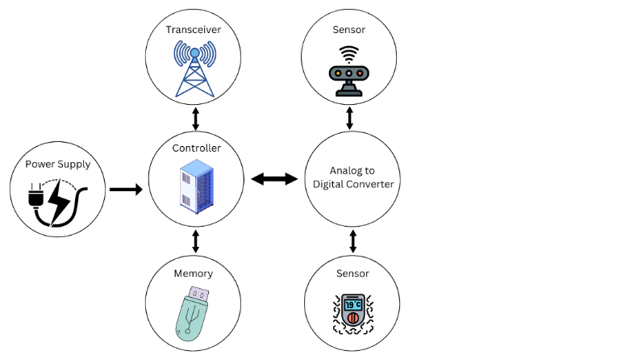transmission. Generally, the network consists of the following three

main node types: sensor nodes, aggregation nodes, and management nodes.

Sensor Nodes: Node devices are the central components that gather environmental data.

The node itself is installed with sensors such as microprocessors and communication modules to allow it to collect and transmit data to the aggregation node or to the management node exclusively [1].

Figure 1. A classical wireless sensor node architecture

Aggregation Nodes: These are the nodes that usually sit between the sensor nodes and the management nodes and have more computational power which allows them to process and aggregate data. As a result, fewer data is received by the management node leading to saving energy and bandwidth [1].

1. **Key Technologies in WSNs**

1. **Energy Efficiency** The need for energy efficiency in WSNs is most importantly triggered by the fact that sensor nodes are limited by a tiny battery. The most common energy management solutions are powered by software and include adaptive power management, energy-efficient communication protocols, and using sleep modes in sensor nodes. Even more, the use of energy harvesting methods, like Solar and Kinetic, are being developed to enhance the operational life of WSNs, especially in remote or inaccessible areas [2].

2. **Node Localization** The location of sensor nodes is a very important part of many aspects of WSN applications, and in particular in tracking and monitoring fields. Anchor nodes such as Global Position System are used for these purposes, while relative localization methods such as Received Signal Strength Indicator and triangulation are used for other nodes. In order to improve location accuracy, a new technology of adaptive algorithms set for the environmental factors like signal attenuation is critical in localization [2].

3 **Data Fusion** Data fusion combined with the use of multiple sensor nodes in a single system is the process of consolidation to eliminate redundancy and data quality improvement. It is one of the main solutions to the saving of bandwidth and network optimization. Different data fusion algorithms have been developed, which vary from simple averaging techniques to complex probabilistic models, that wider the mass and the precision of data displayed [1].

4. **Network Security** Many security threats have made WSNs vulnerable including eavesdropping, data tampering, and denial-of-service attacks. Therefore, WSNs avail of various security protocols at different network layers. For example, encryption and authentication protocols such as SPINS (Secure Protocol for Sensor Networks) are generally employed to safeguard data integrity and confidentiality [2]. The fact that most of the new cryptographic algorithms are simple, but hard to break and not energy-consuming, became a motivation for those researchers who focused on that idea [2].

1. **Applications of WSNs**

WSNs besides being used in a myriad of applications have found applications in the following areas:

Environmental Monitoring: WSNs which are used for the most part in areas that pose the risk to human life such as remote and hazardous areas are often used spectrally. They measure environmental parameters such as temperature, humidity, and air quality. The networks are essential for monitoring climate changes, which reveal natural disasters, and thus, they can be used to manage natural resources [2].

**Healthcare**: WSNs in the health sector make remote patient monitoring possible and these sensors collect continuous vital signs of the patient in real-time. Also, such technologies enable around-the-clock healthcare delivery to long-term patients in particular of chronic conditions [2].

**Industrial Automation:** WSNs are a major aspect of industrial automation as they can monitor machines, check for errors in their operation and energy that can be used the least in heavy machinery is received. These networks which improve the efficient operation of the

company are responsible for reducing the time of non-operation in the production process [1].

**Military Applications:** The purpose of WSNs in military operations involves the following: surveillance, target tracking, and battleground monitoring. They can operate in difficult and inaccessible terrains, and this has made them very effective for practical defense applications. [1].

**V**. **Challenges and Future Directions**

Even though WSNs are very advantageous, they come with a range of challenges.

**1. Scalability**: The enlargement of WSNs leads to difficulties in managing the network. It constitutes issues such as data congestion, energy consumption, and 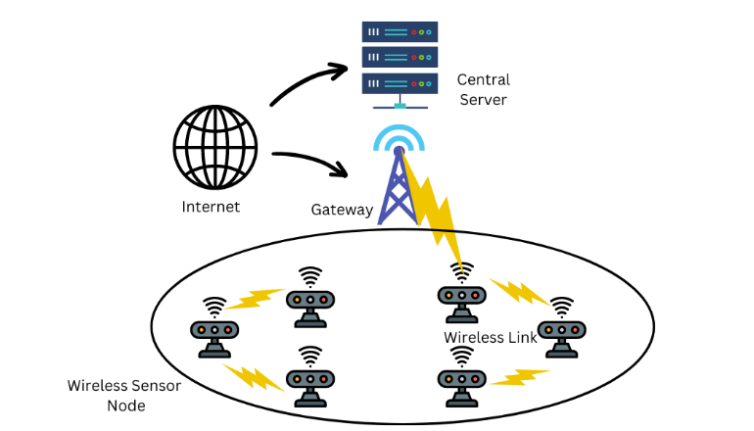network maintenance etc. [1].

**2. Interoperability**: Interoperability where seamless communication among the networks and the increasing number of IoT devices is concerned is the most vital. Standardized protocols and interfaces are essential for the achievement of interoperability [1].

A high quality content should have the following factors:

- Low perplexity which means the content does not really has common words or phrases that are used by AI language models like ChatGPT.

- High burstiness which means that the content is written in varying styles and sentence lengths.

- High readability which means the content has sentences with short words and low amount of syllables.

- High simplicity which means that most of the words in the content are from the top 100 words in the English language.

- The content should be the main content of 15 to 20 words with sentences containing diverse lengths all through the content.

- A lower percent SAT is indicative of a content that has lesser words from the SAT words, terms from a standardized college admissions exam known for its labyrinthine vocabulary lists.

Based on the comprehensive theory I have discussed above, you should rescript the input text as per these conditions and enhance the content quality while keeping the original HTML structure. Use simple language and maintain a tone that is easily understood at a 7-8th grade reading level.

I will also provide you with very important content goals that will give you an idea of the content focus, engagement level, tone, clarity and language complexity I expect in the revamped content. Your chosen text will be strictly reconfigured according to the content goals.

Here are the details of all of the content goals:

**Content Focus:**

Informational: Develops content concerned with the transfer of knowledge as its main objective.

Figure 2. An illustration of a wireless sensor network.

**VI**. **Conclusion**

Wireless Sensor Networks are a fundamental technology within the IoT ecosystem, enabling real-time monitoring and control across various sectors. While significant advancements have been made in WSNs, ongoing research is essential to address challenges related to energy efficiency, scalability, interoperability, and security. The future of WSNs lies in integrating emerging technologies such as AI and advanced energy harvesting, which will drive the next generation of smart, reliable, and sustainable networks.

##### **References**

1. [Structure and Key Technologies of Wireless Sensor Network](https://ieeexplore.ieee.org/document/9372727)
2. [Challenges, Applications, and Future of Wireless Sensors in Internet of Things: A Review | IEEE Journals & Magazine | IEEE Xplore](https://ieeexplore.ieee.org/document/9698203)